SCREENSHOTS FOR MY CLASS WORK BASED ON STRINGS FUNCTIONS

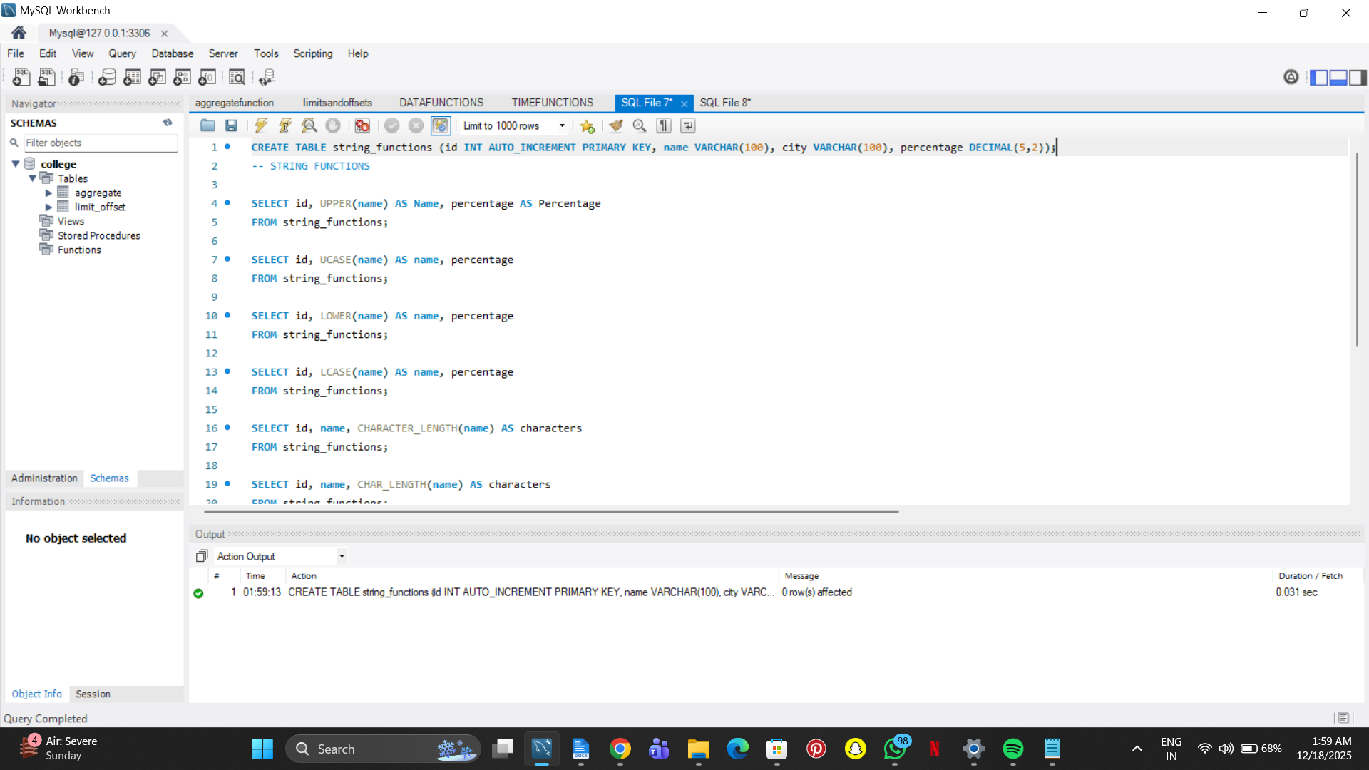

SELECT id, UPPER(name) AS Name, percentage AS Percentage

FROM string_functions;

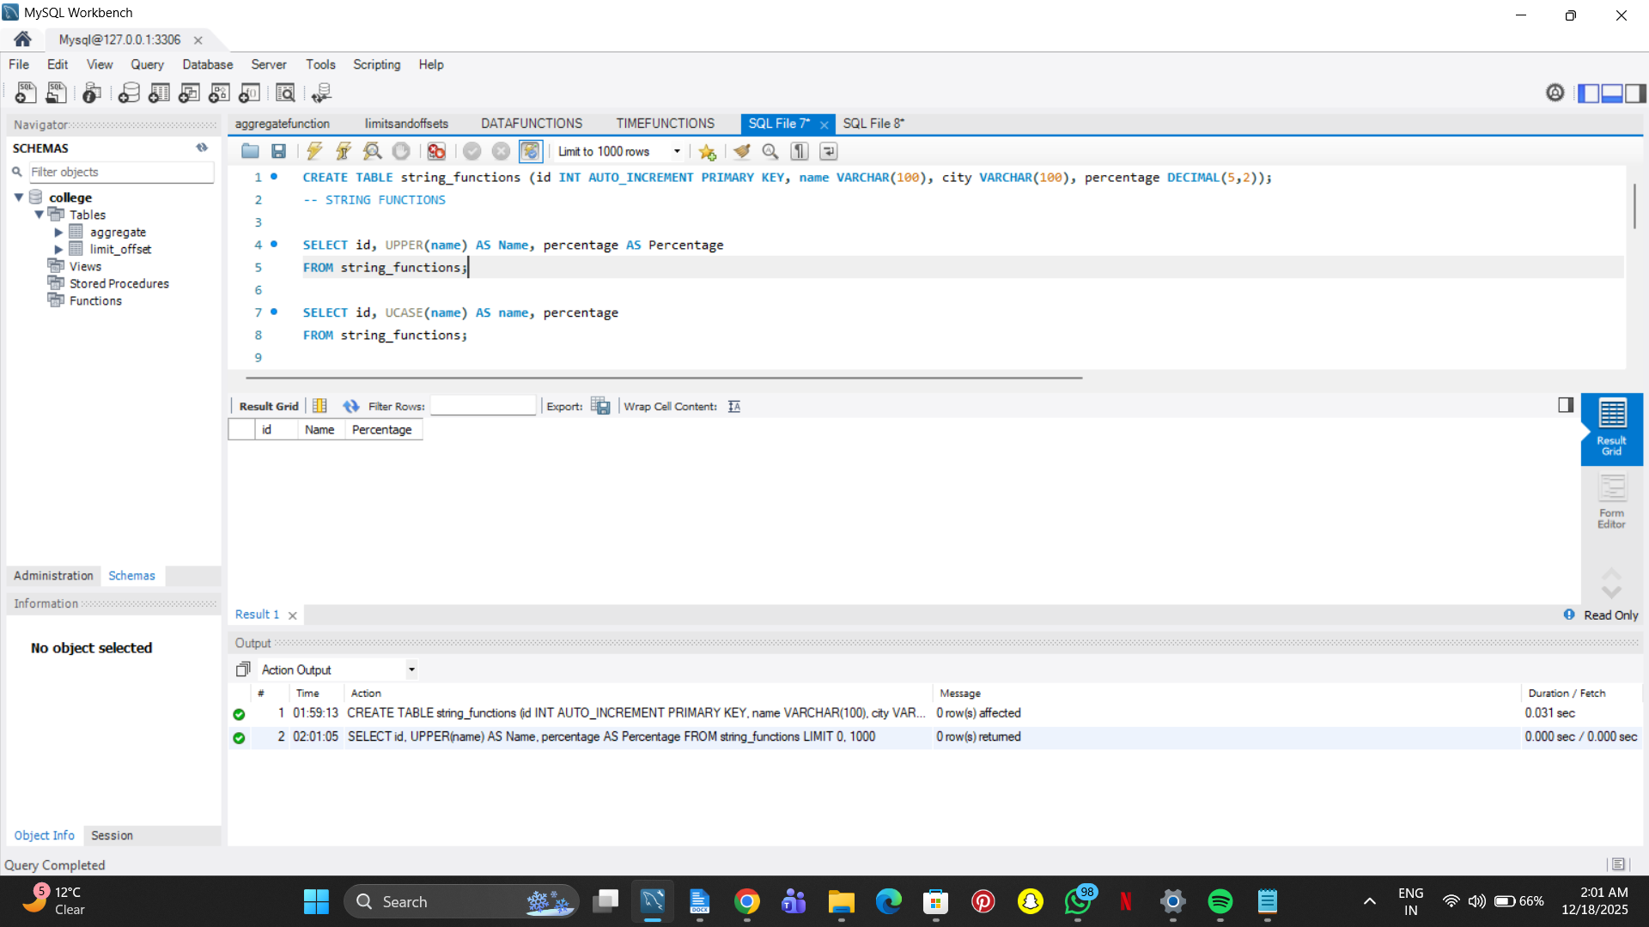

SELECT id, UCASE(name) AS name, percentage

FROM string_functions;

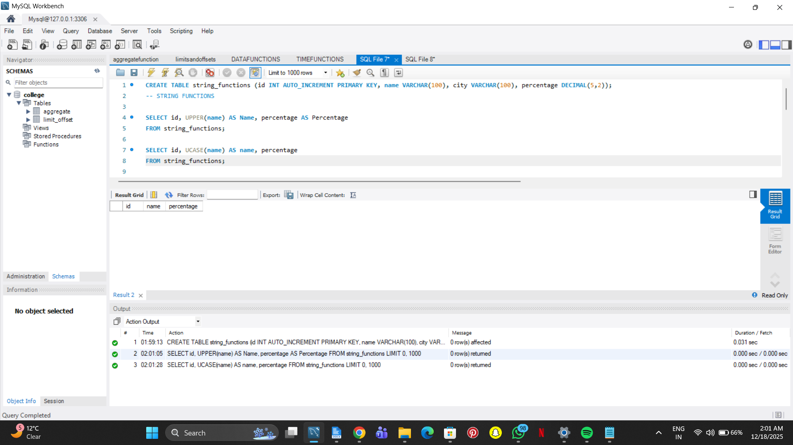

SELECT id, LOWER(name) AS name, percentage

FROM string_functions;

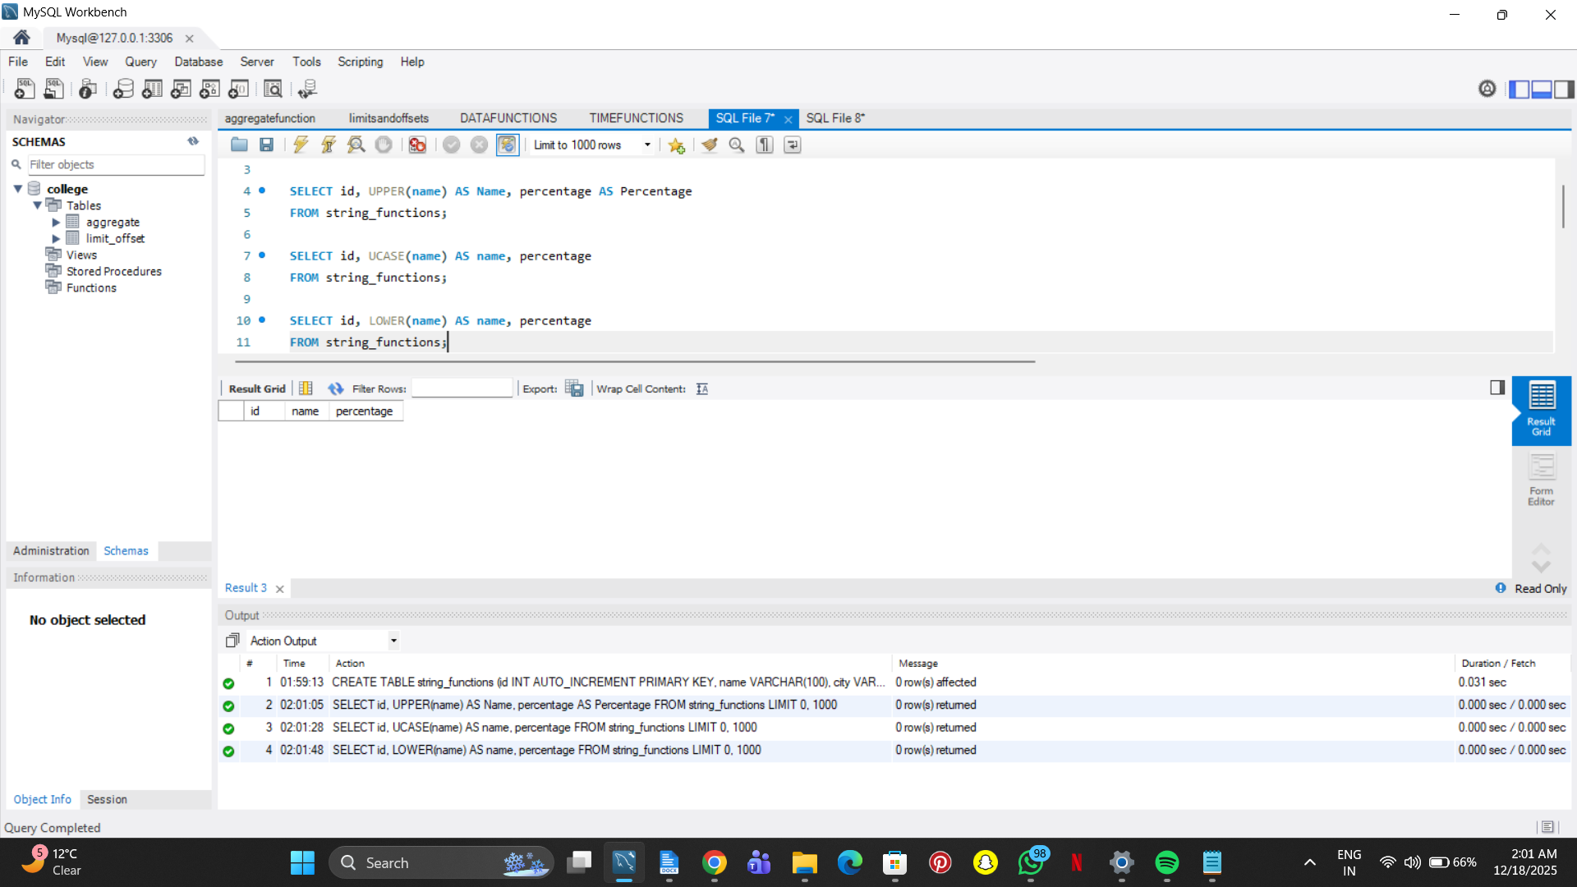

SELECT id, LCASE(name) AS name, percentage

FROM string_functions;

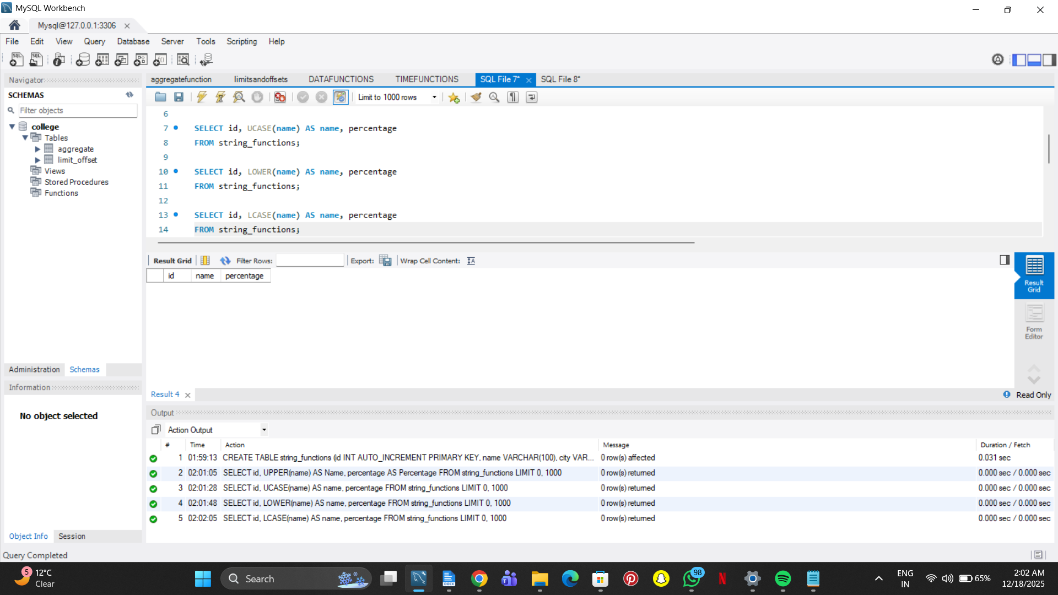

SELECT id, name, CHARACTER_LENGTH(name) AS characters

FROM string_functions;

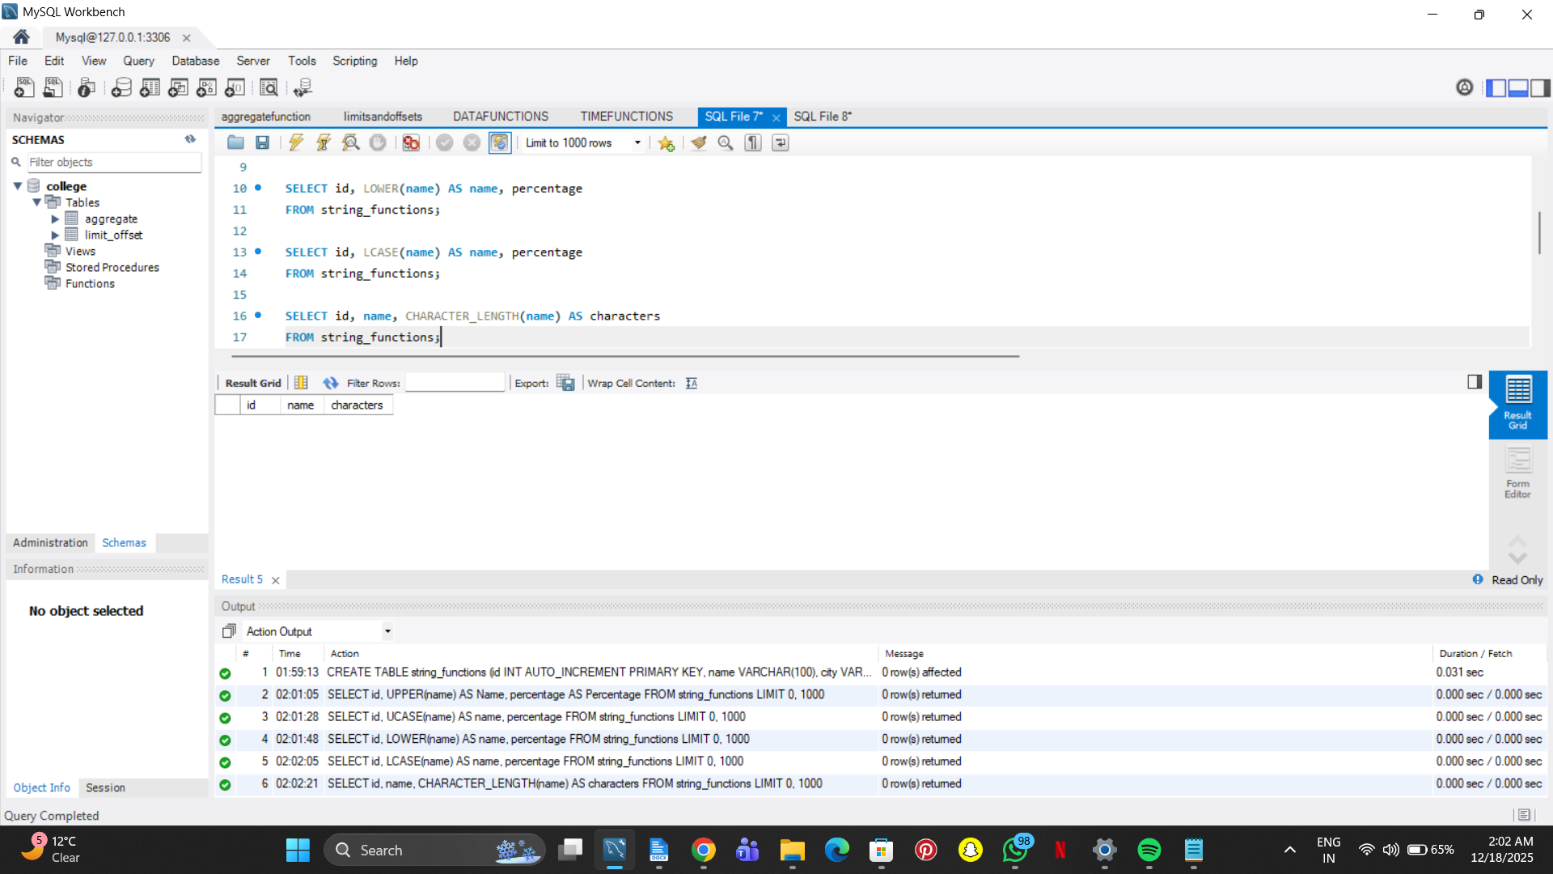

SELECT id, name, CHAR_LENGTH(name) AS characters

FROM string_functions;

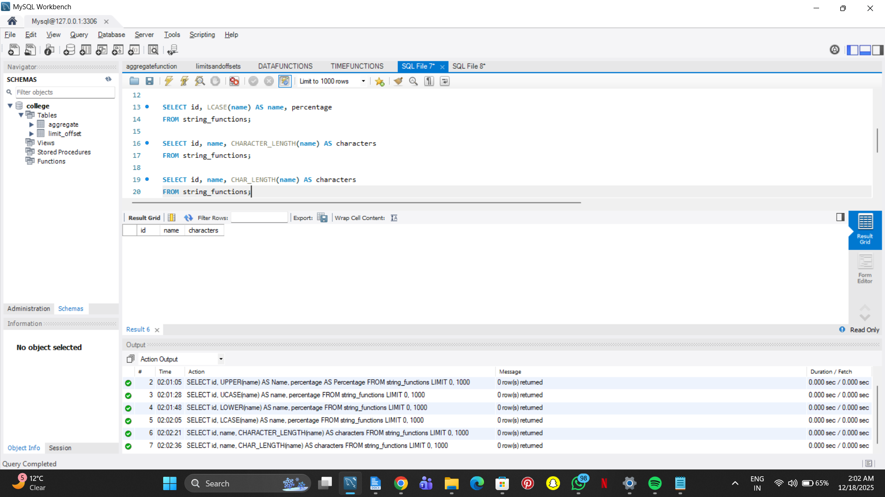

SELECT id, name, LENGTH(name) AS characters

FROM string_functions;

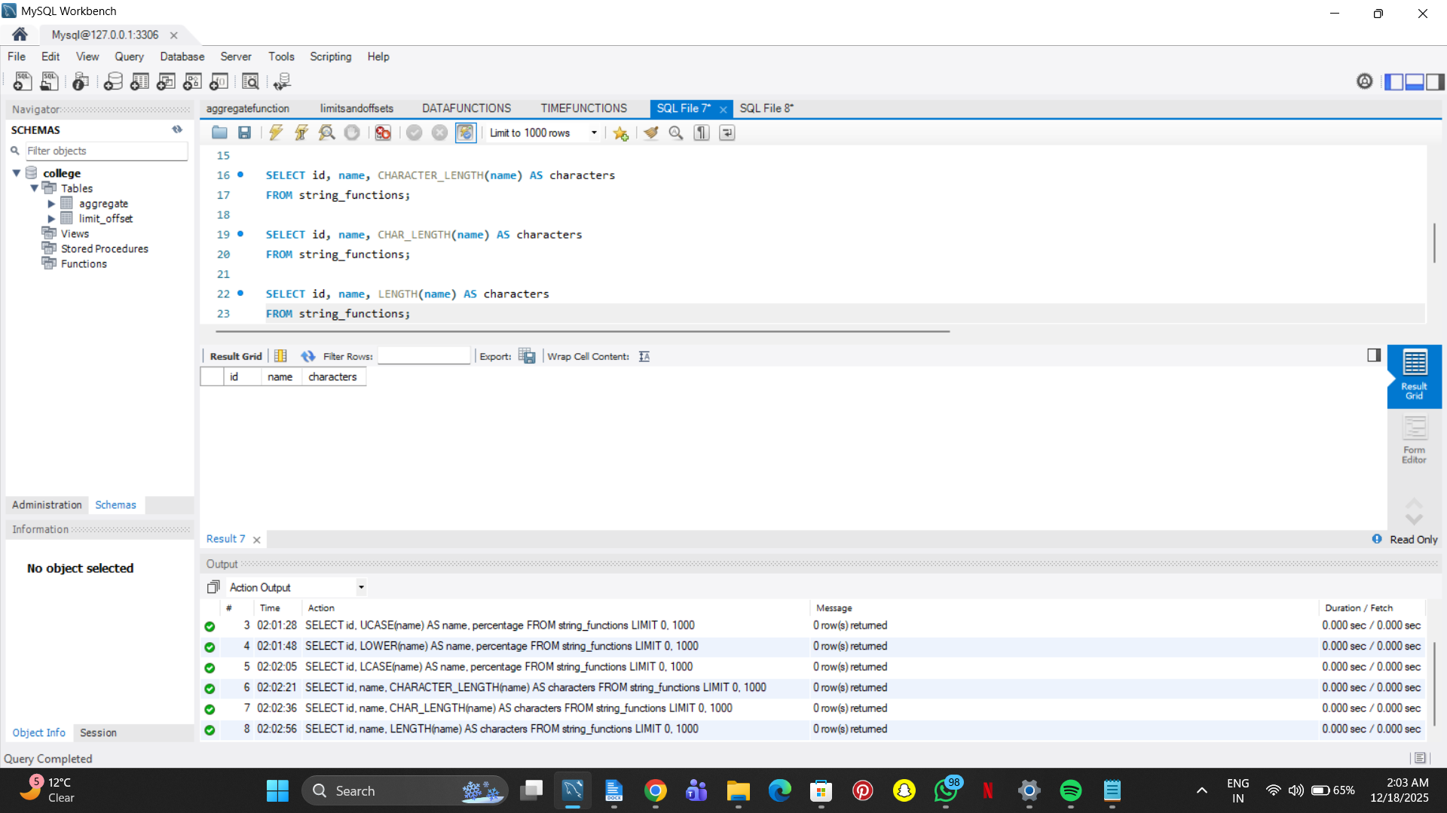

SELECT id, city, CHAR_LENGTH(city) AS characters

FROM string_functions;

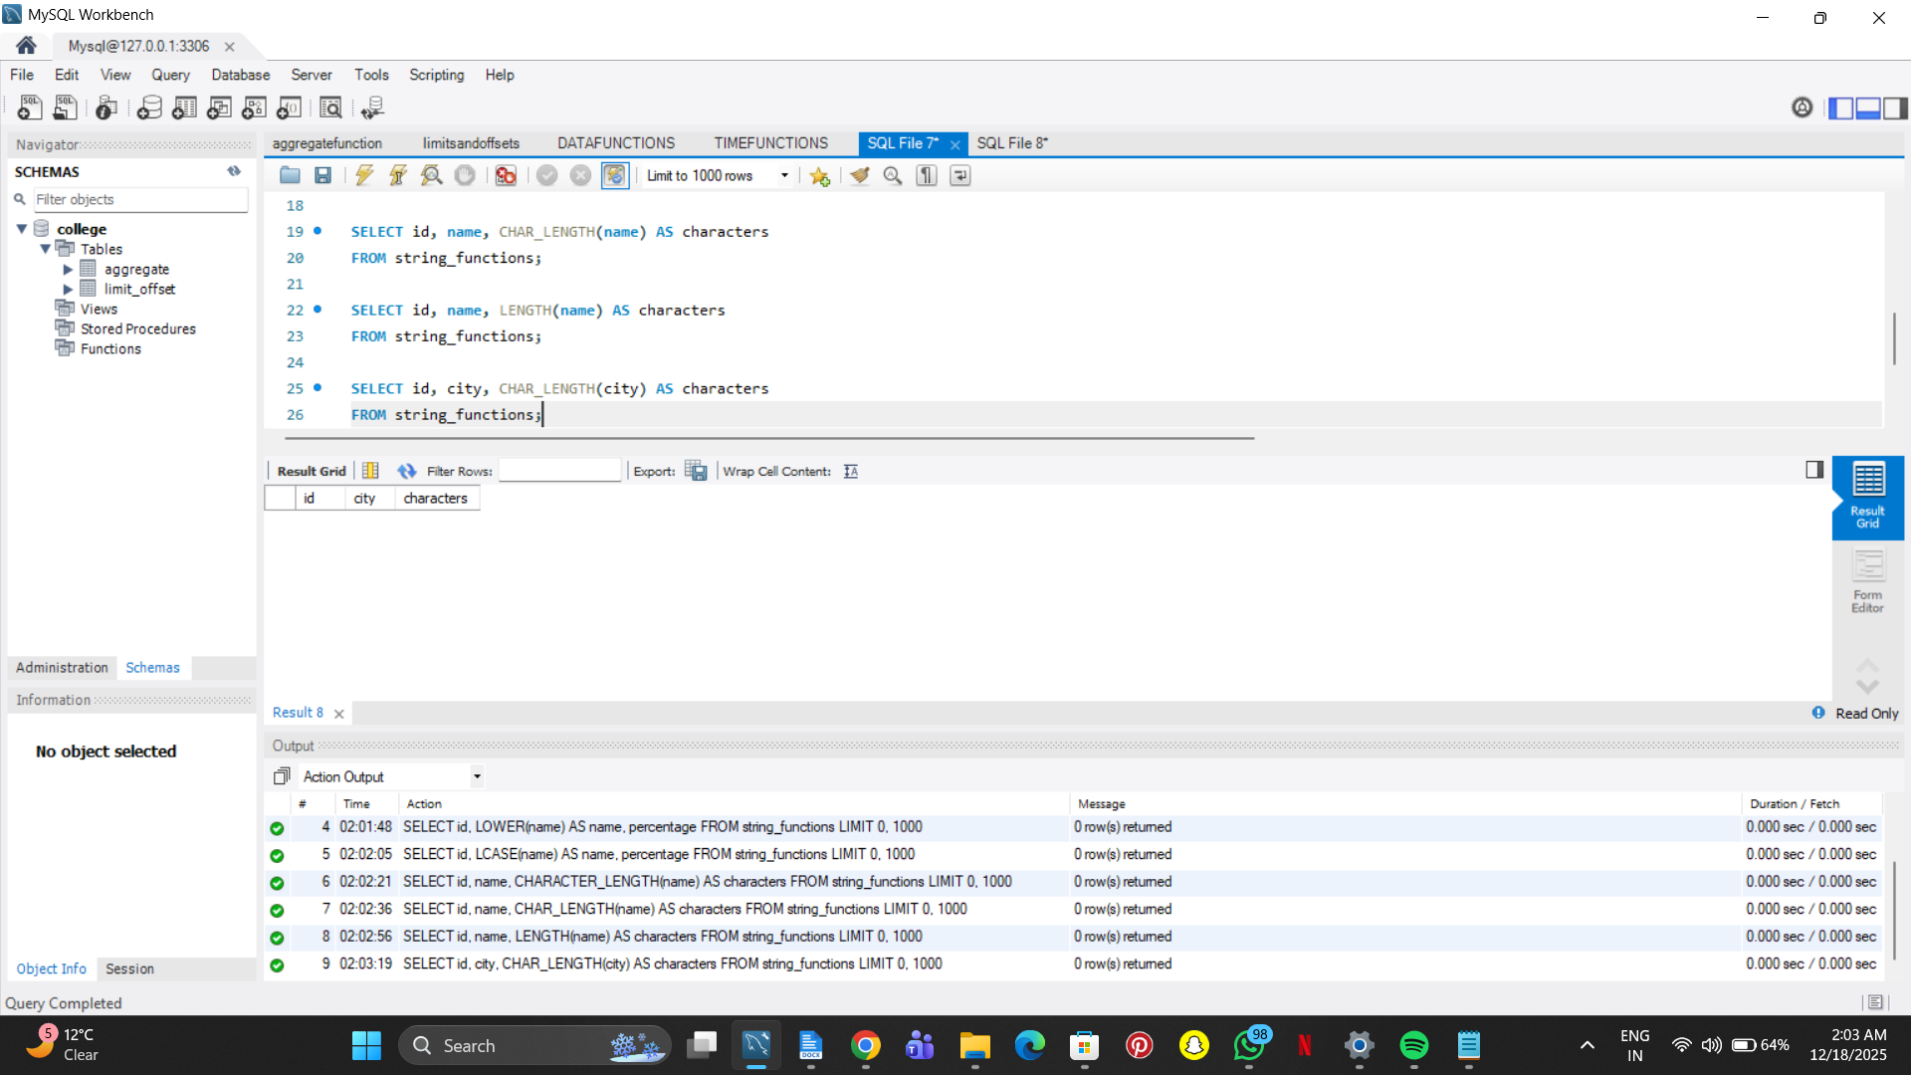

SELECT id, CONCAT(name, percentage) AS name

FROM string_functions;

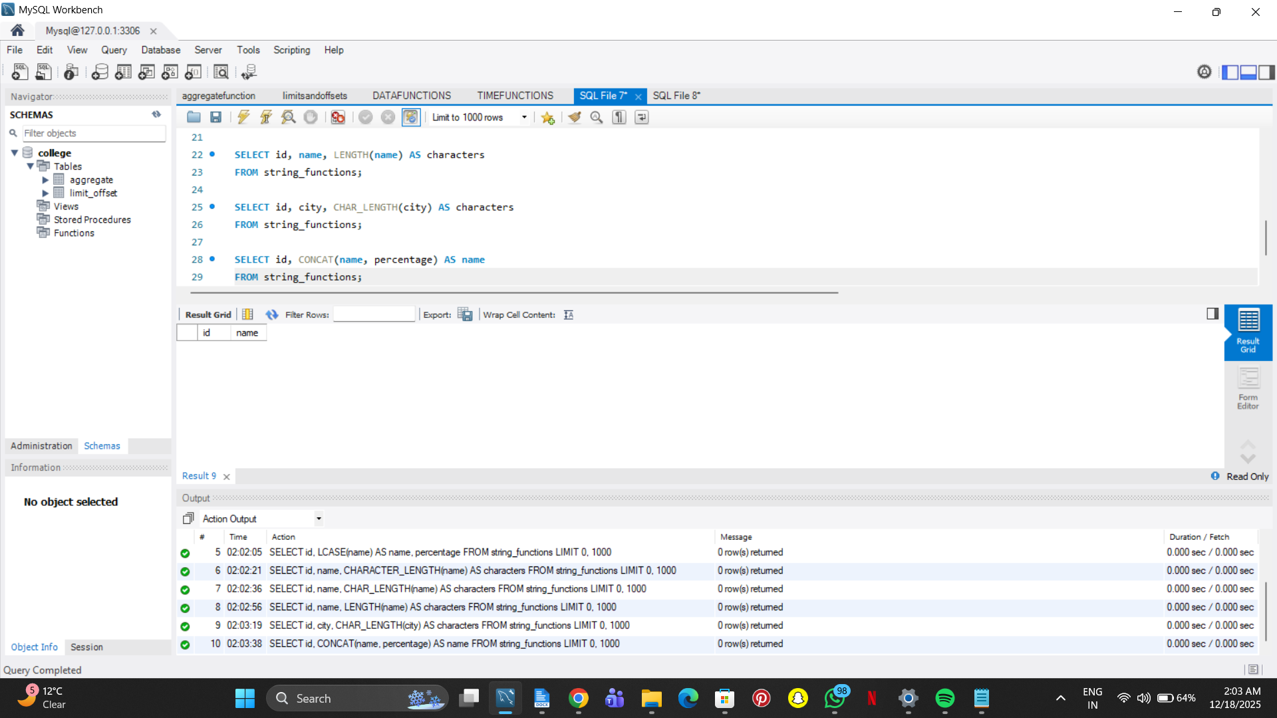

SELECT id, CONCAT(name, '-', percentage) AS name

FROM string_functions;

